1. **Magnetic Design**
   1. Power Calculations

The design of the transformer is one of the most critical parts of flyback topology. The maximum duty cycle for this design is 0.5 and the flyback operates at CCM. To design transformer and choose core, the worst-case Lm can be calculated from the Equation M1 firstly [M1].

$L_{m}=\frac{(V_{min}D_{max})}{2P_{in}f_{s}K_{RF} }$ (M1)

In the equation, Vmin is given as 12V and Dmax is specified before as 0.5. The desired efficiency is 85%. Therefore, from output power requirements, input power can be found as around 56.5W. The Lm can be found as 13.3uH from equation M1. In the next step to find turns ratio, peak and rms current value of primary side must be found. The peak current and rms can be found from the equation M2 and M3 respectively.

$I_{p}=\frac{2P_{in_{max}}}{V_{min}D_{max}}$ (M2) ${I_{p}}_{rms}=I_{P}\sqrt{\frac{D_{max}}{3}}$ 
 (M3)

From equation M2 and M3 peak and rms current can be found as 18.8A and 7.68A respectively. After these parameters are calculated, the saturation of flux density must be specified. Since there is no limitation for this design, Bmax can be selected as 0.3T. With these parameters the core for transformer was selected.

* 1. Core Selection

There are two important parts of core selection. One of them is core type and another one is dimensions and magnetic parameters of the core. In this design, two types of cores were considered because of other cores’ prices. These are powdered core and ferrite core. Even if powdered core store more energy than ferrite core, the ferrite core has higher magnetic permeability for high frequencies. Since the switching frequency of the design is 60kHz, ferrite will be a more reasonable option. This low permeability can cause more leakage inductance for powdered core. Because of these reasons, ferrite core was chosen as core type.

Two ferrite core option was simulated with all calculations. These are 00K3515E090 and E42/21/20-3C94. The effective area of 00K3515E090 is much smaller than E42/21/20-3C94. This is good for core loss and compactness. However, this cause more turns for winding and the transformer will be handmade to change easily for alternative solutions. Therefore, choosing larger effective areas can provide easier production process for transformer. Therefore, E42/21/20-3C94 was selected as core of the flyback transformer. The dimensions and mechanical drawing of the core can be seen in Figure 1.

Figure 1 Dimensions and Parameters of E42/21/20

* 1. Transformer Characteristics and Calculations

Once the core has been determined, the first step will be to decide on the turns ratio of transformer. To decide on this, equation M4 can be used.

$n=\frac{Vin_{min}D_{max}}{(Vout+V_{D})(1-D_{max})}$ (M4)

From M4, turns ratio was found as 0.244. Then the turns number in primary side was found from Equation M5. It is 3.57. Since selecting it as an integer will make easier handmade production, it was rounded to4. Therefore, the turns number of secondary side is 16.

$N_{p}=\frac{L_{m}I_{p}}{B_{sat}A_{e}}x{10}^{6}$ (M5)

Before cable selection, rms and peak current of the secondary side should be chosen. These can be chosen according to M6 and M7 respectively. From these equations peak and rms current was found as 4.70 A and 1.92 Arms.

(M6)

(M7)

* 1. Cable Selection

To make correct cable selection, firstly area of cable should be determined. To find this areas, current density should be selected. For long cables, current density can be taken as J=5A/mm^2. From this value, copper area primary and secondary current can be calculated with respect to M8.

$A_{copper}=\frac{I_{rms}}{J}$ (M8)

The copper areas of primary and secondary side can be found as 1.53mm^2 and 0.38mm^2 respectively. To choose appropriate cables for the design, American Wire Gauge Table should be checked. From the Table-1, AWG15 cable for primary and AWG 21 can be chosen for secondary side winding. However, the skin depth of the cables should be considered. According to this table, AWG 15 reaches its skin depth limit at 8250 Hz and AWG-21 reaches it at 33 kHz. However, system switching frequency is 60 kHz. So, smaller but parallel cables should be chosen. The AWG-24 is suitable for this design because it reaches its limit at 68 kHz. Finally, AWG-24 was chosen, and it will be paralleled 8 times at primary and 2 times at secondary.

|  |  |  |  |  |  |  |  |  |  |
| --- | --- | --- | --- | --- | --- | --- | --- | --- | --- |
| G gauge | Conductor | Conductor | Conductor cross section in mm2 | Ohms per 1000 ft. | Ohms per km | Maximum amps for chassis wiring | Maximum amps for | Maximum frequency for | Breaking force Soft Annealed Cu 37000 PSI |
| Diameter Inches | Diameter mm | power transmission | 100% skin depth for solid conductor copper |
| **15** | 0.0571 | **1.45034** | **1.65** | 3.184 | 10.44352 | 28 | 4.7 | 8250 Hz | 94 lbs |
| **16** | 0.0508 | **1.29032** | **1.31** | 4.016 | 13.17248 | 22 | 3.7 | 11 k Hz | 75 lbs |
| **17** | 0.0453 | **1.15062** | **1.04** | 5.064 | 16.60992 | 19 | 2.9 | 13 k Hz | 59 lbs |
| **18** | 0.0403 | **1.02362** | **0.823** | 6.385 | 20.9428 | 16 | 2.3 | 17 kHz | 47 lbs |
| **19** | 0.0359 | **0.91186** | **0.653** | 8.051 | 26.40728 | 14 | 1.8 | 21 kHz | 37 lbs |
| **20** | 0.032 | **0.8128** | **0.519** | 10.15 | 33.292 | 11 | 1.5 | 27 kHz | 29 lbs |
| **21** | 0.0285 | **0.7239** | **0.412** | 12.8 | 41.984 | 9 | 1.2 | 33 kHz | 23 lbs |
| **22** | 0.0253 | **0.64516** | **0.327** | 16.14 | 52.9392 | 7 | 0.92 | 42 kHz | 18 lbs |
| **23** | 0.0226 | **0.57404** | **0.259** | 20.36 | 66.7808 | 4.7 | 0.729 | 53 kHz | 14.5 lbs |
| **24** | 0.0201 | **0.51054** | **0.205** | 25.67 | 84.1976 | 3.5 | 0.577 | 68 kHz | 11.5 lbs |
| **25** | 0.0179 | **0.45466** | **0.162** | 32.37 | 106.1736 | 2.7 | 0.457 | 85 kHz | 9 lbs |
| **26** | 0.0159 | **0.40386** | **0.128** | 40.81 | 133.8568 | 2.2 | 0.361 | 107 kHz | 7.2 lbs |

Table *3*- American Wire Gauge (AWG) Conductor Table

* 1. Air Gap

The core is ferrite core. To prevent saturation of the core, an air gap is necessary for this core. The air gap of the core can be calculated by using Equation M9.

$Air gap=\frac{A_{e }µ}{A_{L}}$ (M9)

From the equation, airgap for the core can be found as 4.5mm. However, E42/21/20-3C94 is gapless core. Therefore, 1.5mm gap will be okey since all three legs of core will have this gap.

* 1. Core and Copper Loss

To design transformer of flyback, all parameters is considered. However, the performance of the transformer should be calculated to see efficiency of overall system. The core loss can be found by using Steinmetz’ Equation.

$P_{core}=af^{x}B^{y}V_{core}$ (M9)

The a, x and y values can be found at the core’s datasheet. Ferroxcube provides a excel sheet for these coefficients. From this sheet, a, x and y are 3.530102481, 1.419999968 and 2.884999936 respectively. The volume of the core can be calculated from dimensions of core and it is 5130mm^3. When these parameters are put to equation M9, core loss can be found as 2.52W.

$$P_{core}=\left(3.53\right){\left(60000\right)}^{1.42}{0.3}^{2.88}\left(5130*{10}^{3}\right)=2.52W$$

The other loss is copper loss of the transformer. To find cupper loss, resistivity of coppers should be found firstly. The resistivity can be found with respect to the equation M10.

$R=\frac{N*MLT}{(\# of parallel cables)}$ (M10)

From this equation, resistivity of primary and secondary side can be found as 2.47mΩ and 39.5mΩ respectively. The cupper loss can be calculated by using equation M11.

(M11)

* 1. Production of Transformer

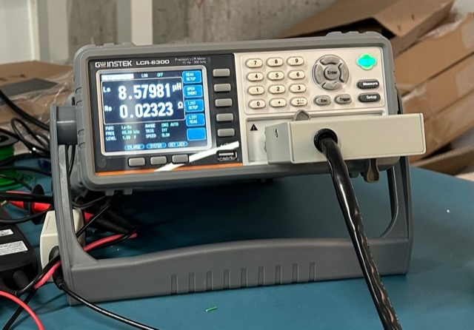

Figure 2 Primary Side Inductance of First Transformer

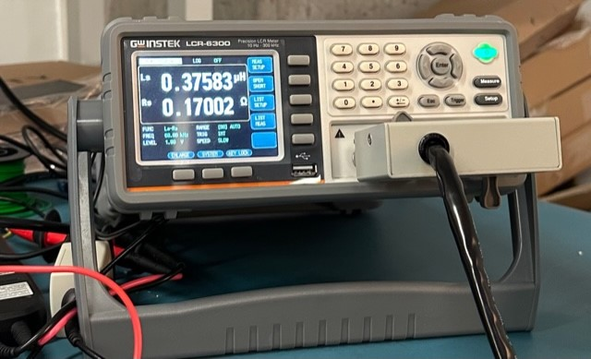

Figure 3 Leakage Inductance of First Transformer

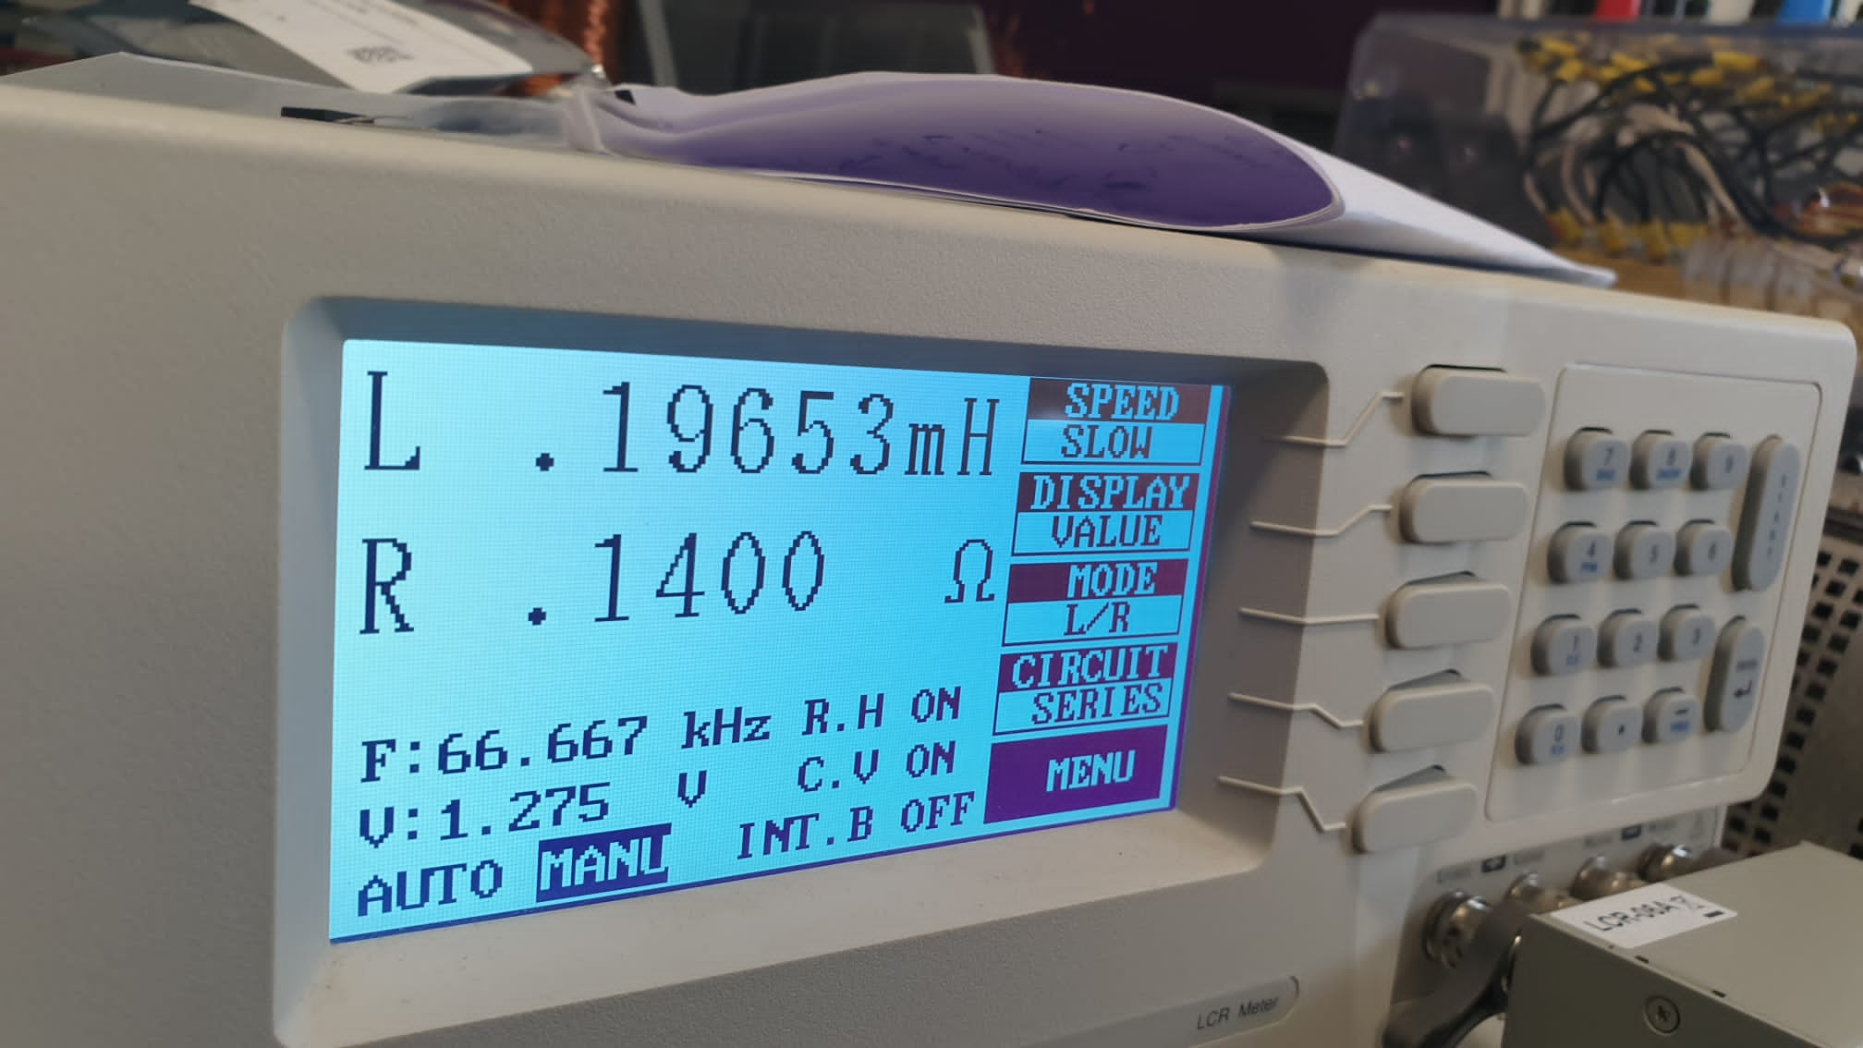

Figure 4 Primary Side Inductance of Second Transformer

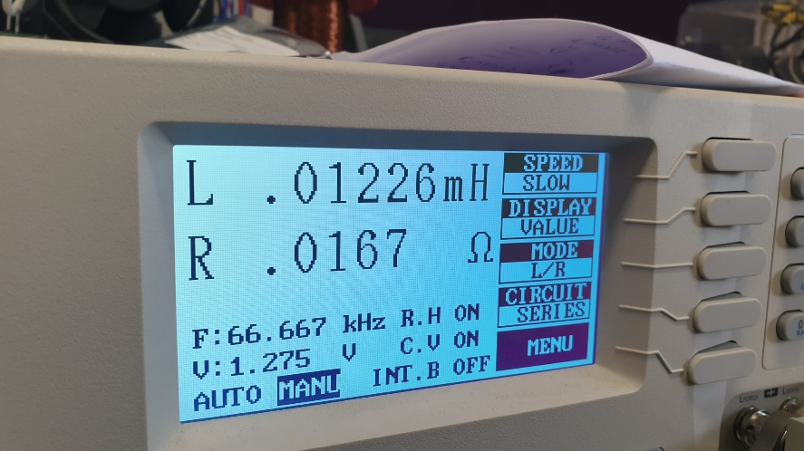

Figure 5 Secondary Side Inductance of Second Transformer

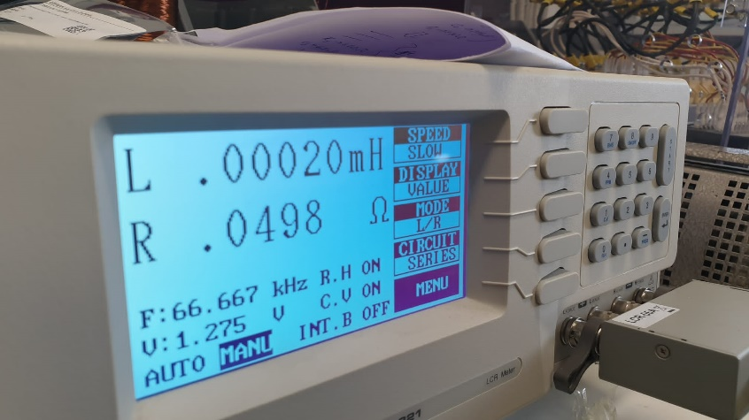

Figure 6 Leakage Inductance of Second Transformer